NATIONAL FOOD AND VETERINARY RISK ASSESSMENT INSTITUTE
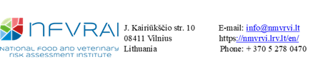
  NFVRAI USE ONLY
  Sample ref. no:
  Date Received:
  Time:
  Sample was
  received by:
Request for detection of rabies antibodies
SAMPLING INSTRUCTIONS:  - Send a minimum of 1 ml serum (or 3-4 ml clotted blood)  - Clearly mark the sample with microchip number (or Tattoo No.)  DESTINATION COUNTRY: | Send SAMPLE TO:  National Food and Veterinary Risk Assessment Institute (NFVRAI)  J. Kairiūkščio str. 10, LT-08411 Vilnius  LITHUANIA
Send Results To*:
(Mark with X)

Owner: Vet Clinic:
Would you like your report:
E-mail: Post: Personally:

Owner‘s Details
Please fill in information in BLOCK letters
Name:
Address: Post Code:
E-mail:
Submitting Veterinarian Details
Vet Clinic Name: | Veterinarian Name:
Address:  Post Code: | Signature of veterinarian:
Tel: | Date:
E-mail: | Date:
Animal‘s Details
Microchip Number (or Tattoo No.): | Date of sampling:
Date of birth: | Date of last rabies vaccination:
Species: | Vaccine name:
Breed:

* The test report is sent by post only to the veterinary clinic; the test report can be collected in person by either the animal's owner or a representative of the veterinary clinic.

